12.38: a) Divide the rod into differential masses 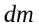 at position l, measured from the right end of the rod. Then , dm = dl (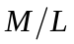), and

dU = 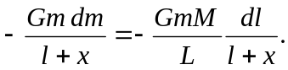

Integrating,
U = 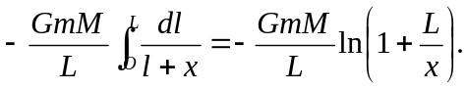

For x >> L, the natural logarithm is 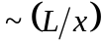, and U 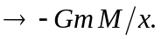 b) The x-component of the gravitational force on the sphere is

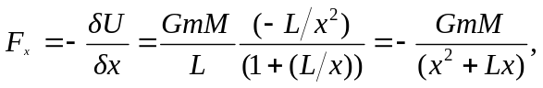
with the minus sign indicating an attractive force. As x >> L, the denominator in the above expression approaches 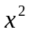, and 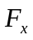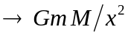, as expected. The derivative may also be taken by expressing
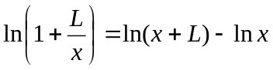

at the cost of a little more algebra.

